Executive Summary of Uber’s NDPO Privacy by Design Assessment Report

Almabrouk Ben-Omran (60104920)

Ali Ranjbar (60101696)

Mohammad Ashjar (60106321)

University of Doha for Science and Technology

DACS 3301 – 1

Dr. Mueen Uddin

June 4, 2024

**Table of Contents**

I.Purpose & Overview 3

II.Key Findings 3

III.Recommendations 4

IV.Visual Elements 5

V.Reflection 6

VI.Conclusion 7

# Purpose & Overview

This assessment aims to evaluate Uber's mobile application in accordance with the standards established by Qatar's National Data Privacy Office (NDPO) under the Personal Data Privacy Protection Law (PDPPL) and the Privacy by Design (PbD) principles. Uber, a globally recognized ride-hailing service, collects and processes a wide array of users' personally identifiable information (PII) and sensitive PII (SPII), such as location data, ride history, payment details, and communication records. The primary objective was to thoroughly examine Uber's security and privacy measures to ensure compliance with industry-leading data protection practices.

# Key Findings

The Privacy by Design evaluation of Uber's mobile app identified various strengths and areas needing improvement. Key highlights include:

**Strengths:**

* **Robust Access Controls:** Uber employs effective role-based access control (RBAC) mechanisms, limiting data access to authorized personnel.
* **Comprehensive Data Encryption:** Data in transit and at rest is encrypted, bolstering the security of personal information.
* **Regular Privacy Notices:** Users are informed about data processing activities through clear and accessible privacy notices.

**Concerns:**

* **Inconsistent Anonymization:** The process for anonymizing or de-identifying personal data is not consistently applied, raising the risk of data misuse.
* **Data Retention Policy Gaps:** Uber lacks strict enforcement of data retention policies, potentially leading to over-retention of personal data.
* **Third-Party Data Sharing:** There is a need for more stringent processes to ensure personal data is shared with third parties only for specific, necessary processing activities.
* **Audit Logging Deficiencies:** Inconsistent audit logging reduces the ability to effectively track and review system activities.

# Recommendations

To enhance Uber's privacy practices and combat the aforementioned concerns, the following measures are proposed:

* **Develop and Implement Anonymization Techniques:** Define use cases for data anonymization, select appropriate techniques such as data masking and generalization, and periodically review these practices to ensure their effectiveness.
* **Enforce Data Retention Policies:** Develop a comprehensive data retention framework, implement technical controls to enforce retention periods, and automate data deletion processes.
* **Strengthen Third-Party Data Sharing Controls:** Regularly verify third-party processing activities against privacy notices and restrict data sharing to only necessary attributes.
* **Enable and Maintain Audit Logs:** Identify key activities requiring logging, securely store audit logs, and perform regular reviews to detect and address anomalies.

# Visual Elements

The accompanying chart illustrates the overall effectiveness of Uber's privacy controls, categorizing them into effective, partially effective, ineffective, or not applicable. Moreover, the bar graph visualizes the effectiveness of these controls across various pivotal domains.

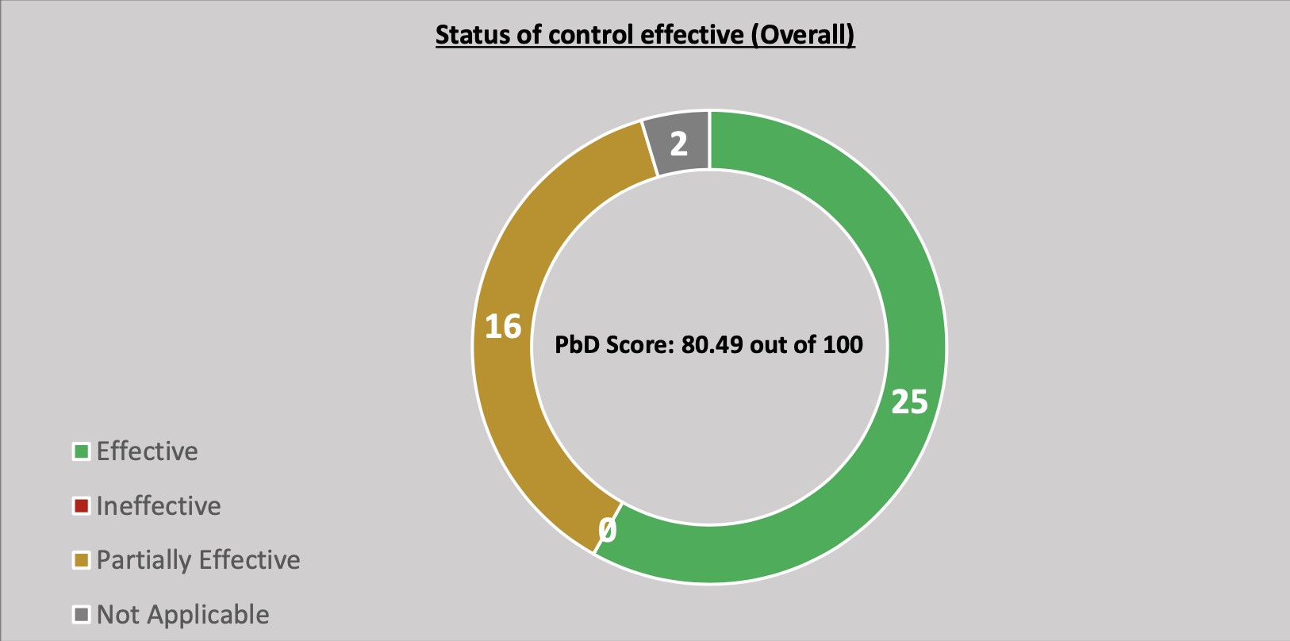

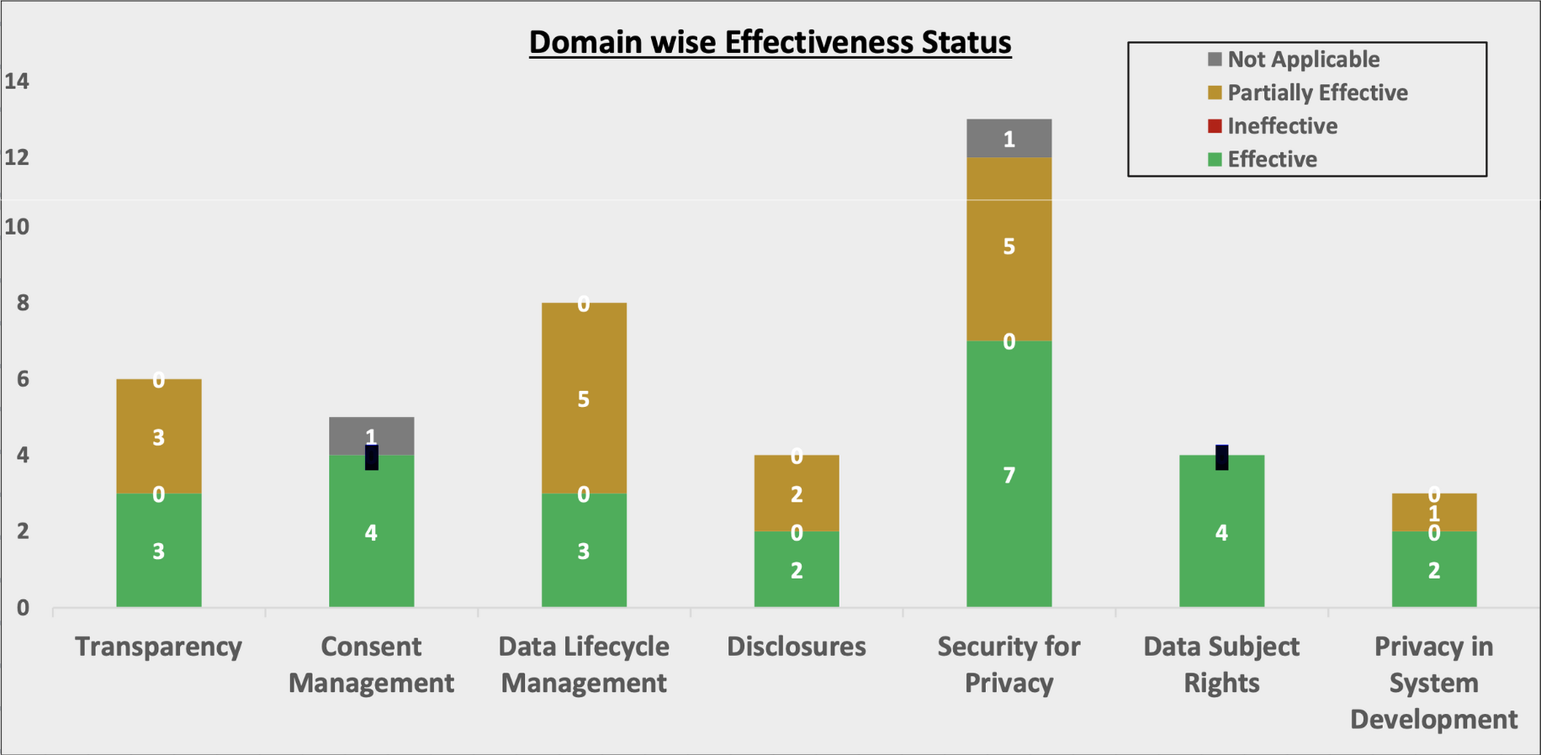

# Reflection

During our assessment, obtaining detailed information on Uber's internal data handling practices and third-party agreements proved to be challenging. Most of the data used was derived from Uber’s publicly available privacy notice. Despite these challenges, the assessment underscored the critical importance of rigorous privacy controls and the need for continuous improvement in data protection measures. While Uber has implemented several vigorous privacy practices, significant areas require attention to fully comply with PDPPL requirements and PbD principles.

# Conclusion

Privacy is paramount in app design, especially for applications like Uber that handle substantial volumes of personal data. This assessment provided valuable insights into Uber's privacy practices, accentuating strengths and areas for enhancement. By implementing the recommended measures, Uber can enhance compliance with PDPPL and PbD principles, thereby increasing user trust and data security.